Workshop on Emerging Communications, Networks and Architectures Technologies for NASA Enterprises


August 7 - 10, 2001
Cleveland Sheraton Airport Hotel
Cleveland, Ohio

Breakout Session Results
Presented by Kul Bhasin, Ph.D.
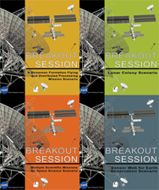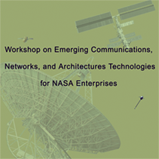

Breakout Session Scenarios | Chair | Facilitators
Lunar Colony | Kunath, Richard | Tseng, Shirley
Sensor Web for Earth Observation | Connerton, Robert | Sands, Scott
Multiple Scientific Missions for Space Science | Nilsen, Erik | Sloane, Greg
A Formation Flying and Distributed Processing Mission | Hayden, Jeff | Runyon, Grant

High Rate Data Delivery Program NASA Glenn Research Center
Prepared by Mr. Jeff Hayden, NASA GRC/IGT

Executive Summary
The Workshop on Emerging Communications, Networks and Architectures Technologies for NASA Enterprises was held on August 7-10, 2001 at the Sheraton Airport Hotel in Cleveland, Ohio. The purpose of the workshop was twofold: 1) review the status of NASA’s communications technology developments being performed under the purview of the High Rate Data Distribution (HRDD) program operated from the Glenn Research Center (GRC) in Cleveland, Ohio; and 2) utilize breakout sessions made up of the attendees of the workshop to analyze four scenarios for illustrating how the developing technologies might be used and for identifying the gaps in technology that will have to be worked on in the future. The findings of the breakout sessions are discussed in this report.
Each breakout sessions focused on one of four scenarios. The scenarios, which are discussed in detail at the end of the report, included:
- A Sensor Web for Earth Observation,
- Multiple Scientific Missions for Space Science,
- A Lunar Colony, and
- A Formation Flying and Distributed Processing Mission.
The findings obtained by the attendees of each of the breakout session discussions were roughly divided into three areas:
- Further questions, ideas, and comments that were aimed at improving a scenario’s concepts.
- General findings and assumptions that set the basic ground rules and requirements for a scenario.
- Identification of the technologies needed at each of the network layers of the architectural elements (backbone, access, inter-spacecraft, and proximity links) addressed by a particular scenario.
The need for high data rate capability in most applications was apparent in the findings, as was the strong emphasis on providing the capabilities of modern networks to enable the scenarios.
The technologies identified in the findings as critical in implementing the capabilities needed in the scenarios include:
- RF hardware in the 30 GHz and higher range and laser communications hardware.
- On-board, standardized networking hardware and software that enables end-to-end transparent communications across Internet and Intranet structures.
- High data rate, wireless local networking that includes capability for measuring relative position information between spacecraft.
- Low power and mass hardware.
- Technologies that provide the ability to operate autonomously and to form and communicate through ad hoc networks.
- Technologies that enable secure and reliable communications.

Methodology
Four scenarios (each described in section VI, below) requiring new technological solutions were analyzed in special breakout sessions during the workshop. The scenarios were used to provide a varied set of missions to highlight use of NASA’s new communications architectural elements: backbone networks, access links, inter-spacecraft communications links, and proximity links. The task given to the attendees of each breakout session was to identify the technologies needed to implement the architectural elements at the communication and networking layers (physical, data, network, transport, and application layers).
In summary, the scenarios were:
- Sensor Web for Earth Observation – In this scenario, Earth-orbiting spacecraft are equipped with the ability to inter-communicate directly. The scenario poses that inter-satellite communications enables in-space cooperation between dissimilar missions to enhance their science and general Earth-monitoring capability.
- Multiple Scientific Missions for Space Science – A multi-mission investigation targeted to explore an outer planet object, in this case Europa, is the premise of this scenario. The contention of this scenario is that the dissimilar missions can assist each other in achieving their scientific goals if they are able to freely inter-communicate.
- Lunar Colony Scenario – The architecture and technologies for communication between each segment of the support structure for a lunar colony are addressed in this scenario. Very high data rates are assumed to be necessary for inter-entity communications to support real time in-space and on-surface operations. HDTV transmission capability is enabled also to the Earth in this scenario.
- Formation Flying and Distributed Processing Mission – This scenario uses a formation flying set of spacecraft with large diameter ultra-lightweight radar antennas placed in solar orbit at Jupiter’s distance from the sun. The purpose of the mission is to detect and locate objects in the outer reaches of the solar system. It is assumed that high rate inter-spacecraft communications is necessary to enable in-space distributed processing to greatly reduce the quantity of data sent back to Earth – thus reducing the load on the DSN.
It was the intent of these scenarios to identify and flush-out basic requirements for the technologies needed at the layers of each communication link used within a scenario.

Findings from the Breakout Session for the Sensor Web for Earth Observation Scenario
Communications challenges for an earth science sensor web mission scenario were posed for discussion in the breakout session. Many of the findings of this session were an extension in further detail of the posed challenges. Technologies were identified for the Access Links and Proximity Links (or Inter-spacecraft links). Findings are shown in sans-serif italics. The Sensor Web for Earth Observation Scenario is described in section VI, A, below.
For this scenario, new or revised communications equipment would likely be added to future mission spacecraft to enable spacecraft to intercommunicate. This hardware would likely need to be capable of communicating at high rates to spacecraft in different orbits and over distances of several thousand kilometers. Note that these intercommunicating spacecraft actually form an ad hoc network that may continually change in structure if the spacecraft draw near to each other then pull away due to being in differing orbits.
The challenges of this scenario raised further questions and comments from the attendees as follows:
What is the purpose of the sensor web?
- To observe spatial differences in atmosphere; look at the entire earth simultaneously, enable interaction between orbiting elements. Other comments...
  - [Concept could lead to the] death of systems engineering.
  - Sensor web is a series of webs on top of each other
  - NASA becomes an ASP (Application Service Provider?)
What is communication’s role in the sensor web?
- Primarily, for the transfer of ‘management’ data (e.g. service requests). Transfer of sensor data also is of interest.
Other comments on the distinction between management and sensor data:
- Internet data is ‘bursty’ NASA sensor data is continuous.
- System engineering is needed on the high rate, sensor data links.
On addressing the nature of the communications architecture to enable ad hoc yet very high rate data movements between spacecraft in orbit around Earth, the attendee’s findings were:
- Focus on access element,
- Make architecture internet-like,
- Obtain ubiquitous low rate links with access to high rate links, as needed,
- Use ubiquitous ground terminals,
- The tradeoffs between mothership/computing node spacecraft (for processing on-orbit) vs earthbound channel capacity must be investigated.
The attendees identified new and/or modified hardware and software that are needed to support inter-spacecraft communications in Earth orbit. That hardware and software is identified at each network layer of communications in the following table:
Technologies Needed at the Access Element Layers for the Earth Science Sensor Web Scenario
Layer | Technologies
Application | - Data management/NTP-like services,  - Authentication/authorization/certification,  - Sensor mgmt/control,store+forward/spacecraft resource mgmt
Transport | - Reliable/delay tolerant,network mgmt,  - Rate control,
Network | - IP+intelligent/ad-hoc routing,  - IPSEC,  - Network mgmt,  - QoS/BoD,  - Multicast,traffic mgmt
Data Link | - Intelligent demand/access techniques not requiring time synchronization,  - Encoding/decoding,xmit power mgmt
Physical | - Optical ISL,  - Ka, W,V RF technologies,  - PAAs/multibeam,  - High Power eff modulation,  - Signaling/hailing channel,  - Time synchronization,  - Miniaturization/nano-technologies  - Omni links,  - Apply low-cost RF technologies

Findings from the Breakout Session for the Multiple Scientific Missions for Space Science Scenario
Communications challenges for a multiple space science mission scenario were posed for discussion in the breakout session. Technologies were identified for the various communications links identified in the scenario. Further, a table was constructed to assist in identification of the communications requirements placed on each inter-entity link. The findings of this session are shown in sans-serif italics. The Space Science Scenario is described in section VI, B, below.
Some interesting comments and ideas expressed by the attendees for the Space Science Scenario were as follows:

Perhaps local radiation induced luminescence could be used for precision location finding of the MSLs and rovers (with respect to Europa surface features)?

Perhaps energy could be generated from the variation in Jupiter's magnetic field, as Jupiter rotates below, to enable low power RF?
The following table indicates, in a general fashion, the relative requirements needed for transmitted data volume and the data transmission rates posed for the various links identified between entities in the scenario. The link requirements in the table are sorted by the type of data being transmitted: location data, control data, and science data. The main comment in the table is that the uplink data must be of high reliability.
Table of Inter-entity Requirements for the Space Science Scenario
 |  | Uplink |  |  | Downlink
Link | Content | Volume | Rate | Comments | Volume | Rate | Comments
MSL-Orbiter | Location | Low | Low | High reliability | N/A | N/A
MSL-Orbiter | Control | Low | Low | High reliability | Low | Low
MSL-Orbiter | Science | High | High | High reliability | N/A | N/A
Rover-Orbiter | Location | Low | Low | High reliability | Low | Low
Rover-Orbiter | Control | Low | Low | High reliability | Low | Low
Rover-Orbiter | Science | High | High | High reliability | N/A | N/A
Orbiter-Orbiter | Location | Low | Low | High reliability | Low | Low
Orbiter-Orbiter | Control | Low | Low | High reliability | Low | Low
Orbiter-Orbiter | Science | High | High | High reliability | High | High
Orbiter-Earth | Location | Low | Low | High reliability | N/A | N/A
Orbiter-Earth | Control | Low | Low | High reliability | Low | Low
Orbiter-Earth | Science | High | High | High reliability | N/A | N/A

The technologies identified by the attendees that are needed to support the Space Science Mission at the access and proximity architectural links are shown in the following tables that are sorted by network communication layer:
Technologies Needed at the Access Element Layers for the Space Science Scenario
Layer | Technologies
Application | - Low power ultra stable oscillator for location determination  - High density rad hard memory to allow for retransmission of science data to Earth  - Modifications to GPS algorithms for use in Europa scenario (Only two orbiters in view at one time)  - RF ID generated by ground assets generated by illumination from orbiters (what about optical?)
Data Link | - Forward error correction for transmission of science data
Physical | - Dual communications grid (low speed for control, high speed for science data) either RF/RF, RF/Optical, Optical/Optical ?

Technologies Needed at the Proximity Element Layers for the Space Science Scenario
Layer | Technologies
Application | - Rad hard low power ASIC or processor for data compression and signal processing
Network | - Controlled Area Network (CAN) between point to point (highly reliable)
Physical | - Optical sensor web for MSL

Findings from the Breakout Session for the Lunar Colony Scenario
Communications challenges for a human lunar colony mission scenario were posed for discussion in the breakout session. Technologies were identified and further questions were raised for the various communications links identified in the scenario. The findings of this session are shown in sans-serif italics. The Lunar Colony Scenario is described in section VI, C, below.
Some of the questions, comments, and ideas expressed by the attendees for the Lunar Colony Scenario addressed communication needs not identified in the scenario. These needs were, however, important to an overall lunar colony program. The following are the questions, comments, and ideas expressed by the attendees:
- What communication would be required to support ad-hoc experiments?
- EVA communication - What affect does lunar dust have on the communication link?. How would optical communication devices be kept clean of charged lunar dust particles?
- Lunar missions must accommodate the sharing of the on-moon experience with the public – utilize video gaming technologies.
- Communicate to earth Internet for family communication (without going thru Houston) – make phone call to home like Inmarsat/Commercial ships; can logon to Earth Internet from Moon (IP address for Moon).
- Need to be able to communication through physical barriers and without line of sight.
- Frequency spectrum – current X allocation is only 50 MHz. Ka, and optical are unlimited (Tony Griffith – space exploration office)
The technologies identified by the attendees that are needed to support the Lunar Colony Scenario at the access, inter-spacecraft, and proximity architectural links are shown in the following tables. The technologies are sorted by network communication layer within each table.
Technologies Needed at the Access and Inter-Spacecraft Element Layers for the Lunar Colony Scenario
Layer | Technologies
Application | - Virtual reality interfaces between robots and humans.  - Motorized vehicles/rover – video, 3D video, HDTV to SHM.  - Terrain tracking.  - Intelligence systems – filtering out what is important to send back (save bandwidth) – intelligent data separation.  - Use of reprogrammable software.  - Integrated vehicle health monitoring.  - Medical monitoring for humans (protected as sensitive data).  - Multiple level security protection for data.  - Need lunar positioning system (LPS).  - Compression – MPEG4 object framework (adds latency).
Transport | - Retransmission for missing packets.
Data Link | - Multiple rovers – traffic control, collision avoidance.
Physical | - Multiple band freq antenna, direct sequence, reconfigurable in frequency and radiation pattern.  - X- and Ka-band phased arrays.  - High bandwidth  - Common use antennas across different missions.  - Interleaving different kinds of antennas - random arrays (random placements of elements).  - Low mass antennas.  - Reconfigurable hardware (FPGA).  - Efficient modulation – mixer, amp.
Technologies Needed at the Proximity Element Layers for the Lunar Colony Scenario
Layer | Technologies
Application | - Multiple fixed collection sites – micro probes.  - Multiple mobile rovers.  - Handheld devices on the moon.
Physical | - Surface comm. – drop beacons (like cellular towers or ad-hoc or peer to peer network – Wireless WAN) near SHM.  - Efficient modulation – mixer, amp.  - Very low mass and power devices.

Findings from the Breakout Session for the Formation Flying and Distributed Processing Mission Scenario
Communications challenges for the formation flying and distributed processing mission scenario were posed for discussion in the breakout session. Assumptions and requirements were identified for the inter-spacecraft communications links. Then technologies were identified for inter-spacecraft communications links layers. The findings of this session are shown in sans-serif italics. The Formation Flying and Distributed Processing Mission Scenario is described in section VI, D, below.
The attendees of this breakout session formulated the following assumptions and requirements for the Formation Flying & Distributed Processing Mission Scenario:
- Radar search mode will use very large pulses to detect an object.
- Science mode will use shorter, varied pulses (such as frequency chirps) to obtain detailed data on the detected object.
- The processors aboard the spacecraft in the formation perform extensive, distributed data processing.
- The reduced science data sets are returned to Earth.
- The formation will likely be implemented using a master/slave relationship – a star network that uses a single central spacecraft as the master controller.
- Formation will probably not be co-planar. Instead it will be purposely offset to make it easier to measure out-of-plane distances.
- The inter-spacecraft data rate will not exceed 20 Mbps aggregate
The technologies identified by the attendees that are needed to support the Formation Flying & Distributed Processing Mission Scenario at the layers of the inter-spacecraft architectural links are shown in the table that follows.
Technologies Needed at the Inter-Spacecraft Element Layers for the Formation Flying & Distributed Processing Mission Scenario
Layer | Technologies
Application | - Time – message passing clock synchronization scheme  - Recovery control software  - Position Measurement and control  - Science data reduction software
Network | - Entry point for ranging/position data  - RF – data from physical layer sensor system for distance azimuth and elevation are inserted at this layer  - Time – Ranging and timing data inserted at this layer
Data Link | - 802.11a or W1394 could be a way of achieving inter-spacecraft communications  - Reed-Solomon/Turbo codes
Physical | - If you need to be coplanar, you need an optical system for relative position  - Time and position captured here  - RF - sensor system for distance, azimuth, and elevation.  - Time – Ranging timing captured here  - Time and range beacon – separate RF system  - 802.11a or W1394 could be a way of achieving inter-spacecraft communications - may need modification due to range limitations  - Ability to perform hardware reset and redundancy switching of system

Sensor Web for Earth Observation Scenario
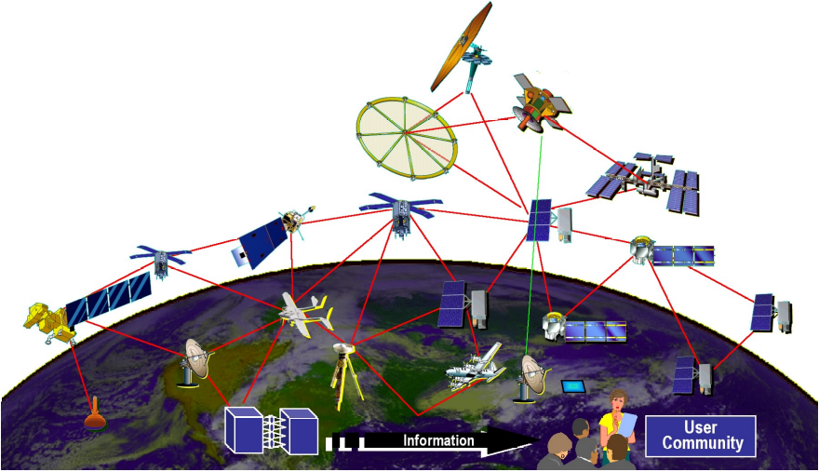
A Scenario for Communicating Between Disparate Missions to Coordinate Earth Science Measurements and Event Detection
NASA wishes to enable all future Earth science mission spacecraft to intercommunicate so that interdisciplinary missions can be implemented across disparate spacecraft and mission types. This intercommunication capability enables a kind of “sensor web” where spacecraft can pass data between themselves to coordinate the study of phenomena and events in the vicinity of and on the Earth. This ad hoc networking capability enables data to be passed rapidly around the Earth to other assets and to the ground without the use of an in-space network such as TDRSS.
A particularly desirable feature of this intercommunication capability is that missions to study certain phenomena, say pollution for example, could be upgraded as time goes on by adding new instrumentation on new spacecraft that could be made to fly in formation with an older spacecraft to augment and improve the pollution study. The inter-spacecraft communications would be used to coordinate measurements made by each spacecraft as well as enable a distributed processing feature that would allow a higher degree of data reduction in-space by newer and more capable spacecraft computers as they are brought into space.

Multiple Scientific Missions for Space Science Scenario
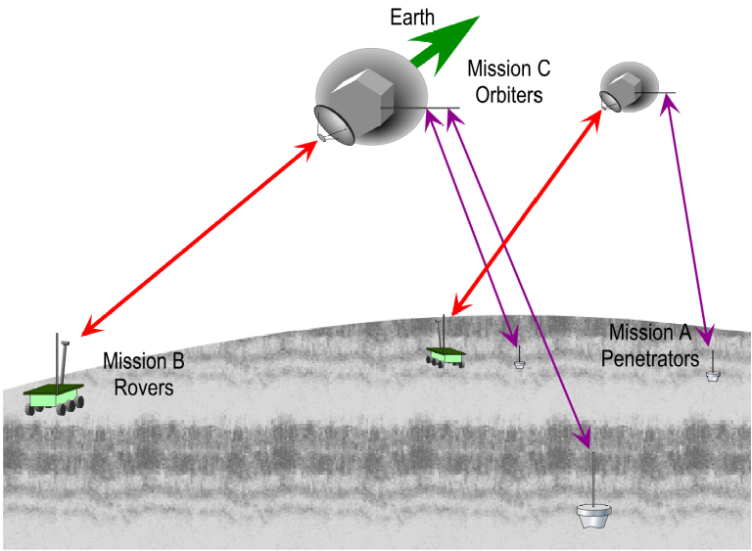
A Scenario for Handling Communications to, from, and between multiple Space Science Missions
Assume a multi-mission investigation targeted to explore Europa. The set of missions include orbiters, landers, and rovers. While these missions will likely arrive at Europa at different times, the intent, for the purposes of this scenario, is that all segments will be operating simultaneously for a period of time.
The prime science objective of Mission A is the measurement of the dynamics of Europa’s surface, that is, the tidal and seismic activity. This mission employs an orbiter to scatter a set of micro-seismic landers (MSLs) all around Europa. Each very small MSL (10-20kg) is deorbited with retrorockets and impacts Europa’s surface with a penetrating spike that anchors it down. Once landed, an MSL, begins listening for signals from overhead orbiters, begins listening for seismic and sonic activity, and begins transmitting short bursts of identification information.
Mission B utilizes an orbiter to deploy five 40kg Europa Roving Vehicles (ERVs). These are also deorbited with retro-rockets, but they each perform powered soft landings utilizing hazard avoidance control. The prime objective of this mission set is to explore and take in situ measurements of the physical, chemical, and mineral characteristics of the surface of Europa. A secondary objective is to measure seismic and sonic characteristics of the surface of Europa in cooperation with the MSL’s.
A set of 6 small orbiters (200 kg dry each) comprises Mission C. Each orbiter has a significant science package that differs from the others: One orbiter has a gamma-ray spectrometer and neutron detector; a second orbiter has a sensitive magnetometer and energetic particle instrument; a third has an ion and neutral mass spectrometer; a fourth has an ice-penetrating radar; fifth, a radiometer and thermal emission mapper; and the sixth, a package of 10 independently deorbitable seismic bombs. The orbiters also all include a common set of instruments that are used together in performing the overall objectives of this mission set campaign to directly measure the tidal deflections and stresses impressed on Europa by Jupiter. One of these instruments sets include a laser altimeter, an imaging system that continually looks for new cracks in the surface, and a global positioning radio and synchronous timing generator set that is used to track the precise position of each orbiter with respect to each other; and to determine the precise location of each MSL; and to determine the dynamic locations of the rovers.

Lunar Colony Scenario
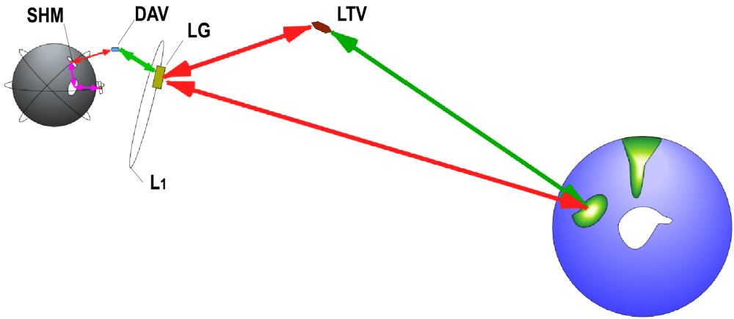

NASA plans on heading back to the moon somewhere in the 2008-10 timeframe. The missions will be configured to either use the moon as a testbed for a later Mars mission or for further lunar exploration or both. The preferred site for a lunar post is near the south pole.

The plan for early implementation is to put a mini space station, called the "lunar gateway" (LG), in orbit about the Earth-Moon (L1) libration point and use it as a staging point for excursions to the lunar surface in the "descent/ascent vehicle" (DAV). Once on the lunar surface, the astronauts will inhabit a previously landed "surface habitation module" (SHM) which will be their base of operations.

There is a desire to support continuous communications regardless whether the astronauts are in the LG, DAV, or SHM, and also including a fourth vehicle, the "lunar transfer vehicle" (LTV) which takes the astronauts from near-Earth orbit to the LG.

To meet these needs, three basic lunar architectures concepts have been identified. Each includes relay satellites in orbit about the moon, but vary in the number of orbital planes, orbiting satellites, and whether or not they relay the communications directly back to Earth or use a relay station on the surface or at L1 or both. The need for agile phased array antennas at both X-band and Ka-band is foreseen for the orbiting satellites to support the anticipated data rates of 10 - 40 Mbps from multiple human and robotic operated surface sites and spacecraft. Inter-spacecraft links, cross links between the communications satellites, and either relay links back to Earth from the communications satellites or from relay stations on the lunar surface are anticipated. The LG or the SHM may also be used as either redundant communications assets or be designed to perform as actual dual-purpose mission/communications system assets.

A Strawman Formation Flying and Distributed Processing Mission Scenario
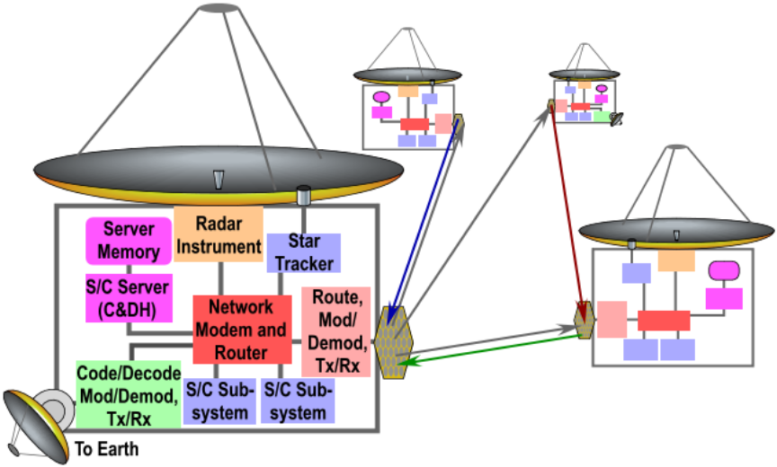
Assume NASA has launched a mission to detect Kuiper Belt and Oort Cloud objects. This mission uses a formation flying set of large diameter ultra-lightweight radar antennas placed at one of Jupiter’s Trojan points, say L_{J5}. To detect and locate objects in the outer reaches of the solar system, these antennas must synchronize their outgoing radar pulses such that they all form a unified wavefront that is pointed in the direction that is being searched. The antennas may be spread close together to improve the strength of the return signal or spread quite far apart to increase the resolution of the direction of the return signals.
One of the antenna spacecraft assumes the role of mission master and coordinates the mission’s operations by determining where to point when firing the radar pulses and how to space-out the formation. The master must know where all the slave antennas are in x, y, and z location relative to the master’s coordinate system; it must inform them where to point; it must coordinate the synchronization of the clocks; and it must inform each slave antenna as to its firing time with respect to the slave’s own clock. The communications system is used to measure the relative positions of each spacecraft in the formation. Pointing of the formation is accomplished using star trackers to locate common point source stars for all spacecraft to stare at while the pulses are fired.
Each antenna listens continuously for return signals whenever it is not firing new pulses. A return signal at a single antenna can be extremely weak and buried in the noise. To improve signal to noise ratio, all return noise and data are digitized, time tagged, and sent to nearby slave antennas for time matching (after time offset correction due to each spacecraft’s out-of-position error with respect to the ideal wavefront) and summing. Summed signals are passed to other slaves for higher level summing until a single summed signal can be searched for return signals. Returned signals that are detected are passed on to Earth.

