Creating and Managing Assessments
Presenter: Saleh Al-shomrani
Website: http://wme.cs.kent.edu/dmad/
Objective: The participants learn new features of assessment system, be able to search DMAD bank for questions, import/export questions from and to the assessment system, and create and manage assessments.

Background
The assessment system (DMAS) is a Web-based Distributed Mathematics Assessment System that can be of great value to teachers and students of Mathematics. The assessment system provides an efficient, effective and systematic way to support the assessment needs of mathematics education and a platform for teachers at different schools to contribute and share assessment materials. It utilizes distributed databases and Web technologies to achieve these functions. It also helps Mathematics teachers to quickly and easily author, edit, administer and manage tests. They can also easily import materials from or share questions with other teachers either from same or different schools. Here is the DMAS assessment system overview:

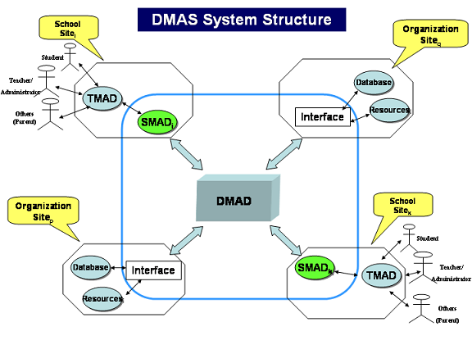
Figure A1: DMAS Assessment System Structure

The assessment system (DMAS) Features:
- DMAD (the core Distributed Mathematics Assessment database), TMAD (Teachers Assessment Database), SMAD (School Assessment database). DMAD is designed to work as one distributed database while providing power, unity, and convenience at each participating school. The system helps create, revise, administer, and grade exams that can contain various types of questions: MCs, true-or-false, extended (essay) questions, short answers, two-columns matching, and fill-the-blank.
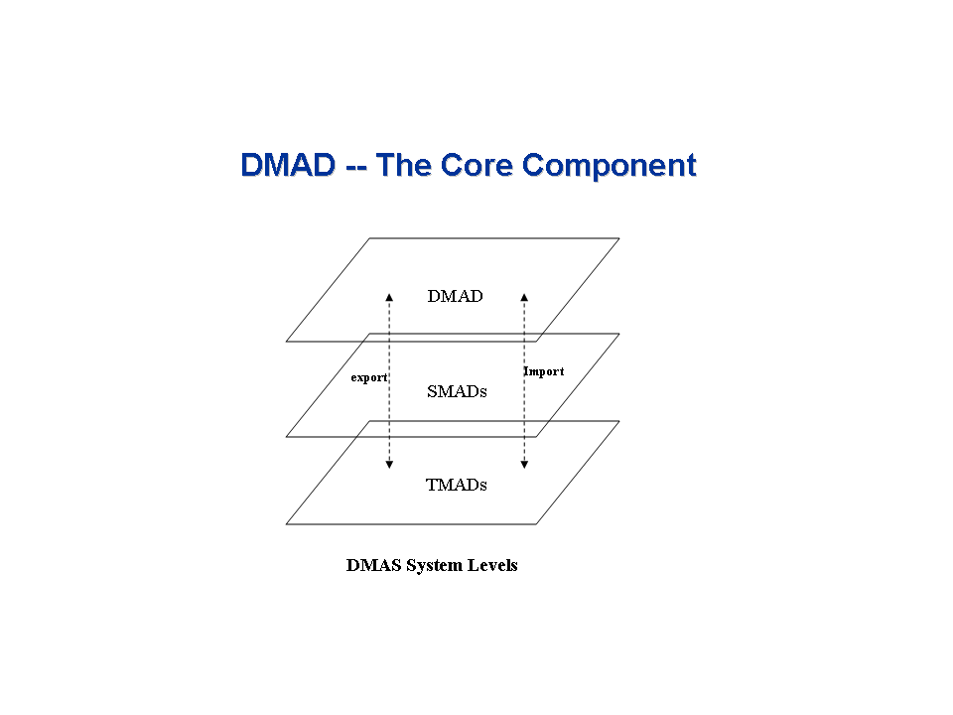
Figure A2: Assessment System Levels

- The assessment system consists of local databases at individual school websites. Each local database collects assessment questions contributed (exported) by teachers in a particular school to be used (copy imported) and perhaps shared with other teachers from same or different schools.
- Teachers can use the powerful search engine (DMASEngine) to search for assessment questions. Search can be narrowed by subject, topic, grade-level, question type, keyword, and author.
- Test authoring tool for teachers, online taking of tests, real-time grading and results administration, comprehension diagnoses and linking to remedial materials.
- A teacher can monitor all students from the teacher terminal in real-time and either verbally guide the whole class on certain points or interact privately with one or more students via Teacher-Student Interaction Mechanism (TSIM) as instant text-messaging provided by the assessment system. Also students can “click” help button asking for help from the teacher.
- The system supports an accumulative submission of test questions so that in case of loss of power to a laptop, closing browser window by mistake, and so on, a student can retake the test, after authorization from the teacher, from the point where she stopped before the problem occurred.
- Completely Web-based.
- Free system!

Although developed as a sub-system of WME (Web-based Mathematics Education), the assessment system (DMAS) is an independent Web system easily interfaced to any Web page through a well-defined interface. This assessment system is an open system implemented with standard Web/Internet and can easily interoperate with other online systems.

Instructions

Activity A1: Navigate/Search the Assessment System

Step A1-1: Please go to the assessment system Website: http://wme.cs.kent.edu/kimpton/assessment/. Image below shows the homepage of the assessment system (DMAS).
Step A1-2: Please use the username/password provided to login to the system. After you successfully log in, the DMAS system will bring you to the main page.

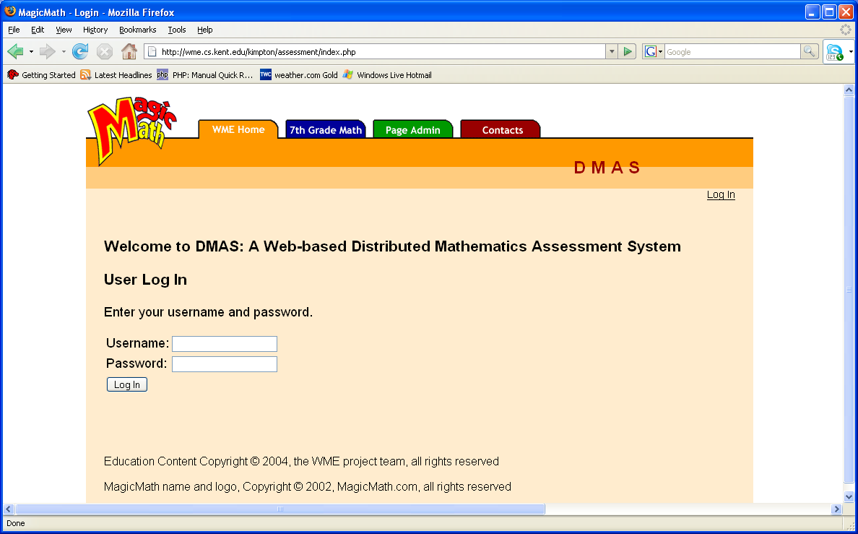
Figure A3: Home page of the Assessment System

Step A1-3: Please take a look at available options:
- "Make A New Test": to create a new assessment test.
- "Manage Tests": to manage your assessment tests such as editing a test, adding or deleting questions, setting test scores, publishing a test, grades administration, etc.
- "Make A New Homework Assignment": to create a new Homework Assignment.
- "Practice Questions": to practice some questions.
- "Manage Homework": to manage your Homework Assignment.
- "Search/Browse DMAD Question Bank": you can use DMASEngine to search for assessment questions or browse DMAD Bank.

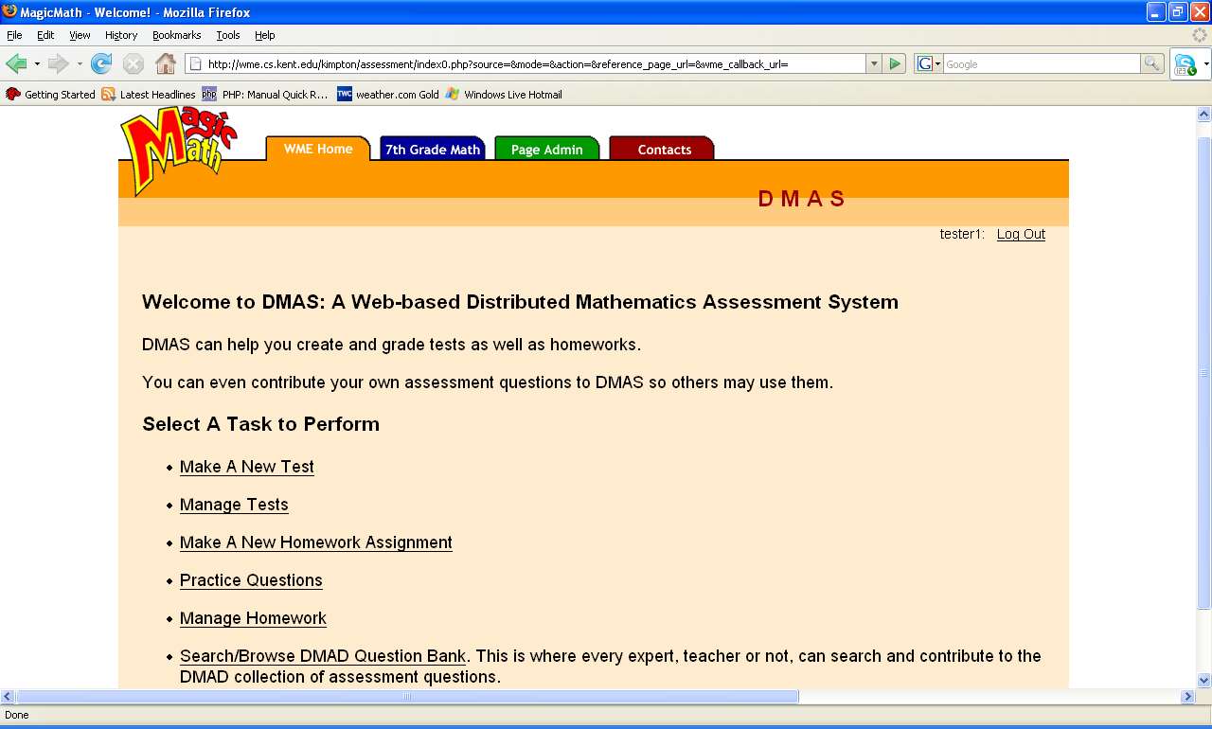
Figure A4: Assessment System Main Page

Step A1-4: Please click on "Search/Browse DMAD Question Bank" to search for assessment questions or to browse DMAD Bank. You can search for text or keywords (if you leave it blank means search for everything) and choose where to search for questions: in your school only or whole question bank from all participating schools.

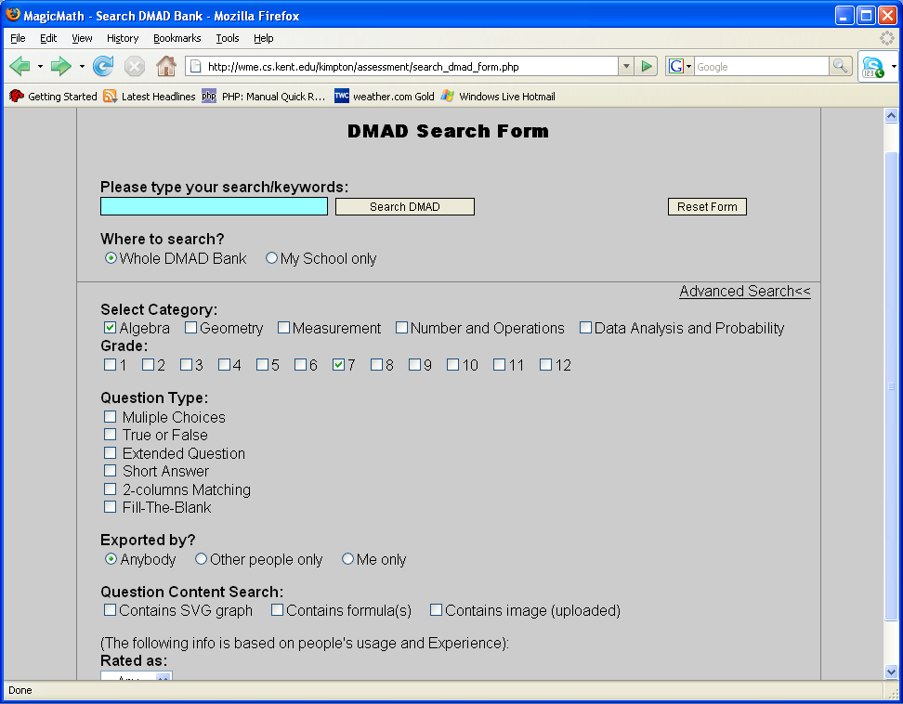
Figure A5: Assessment Search Page

Step A1-5: To narrow you search click the "Advanced search" link so you can search by category, grade, or question type (multiple options from same category are allowed).

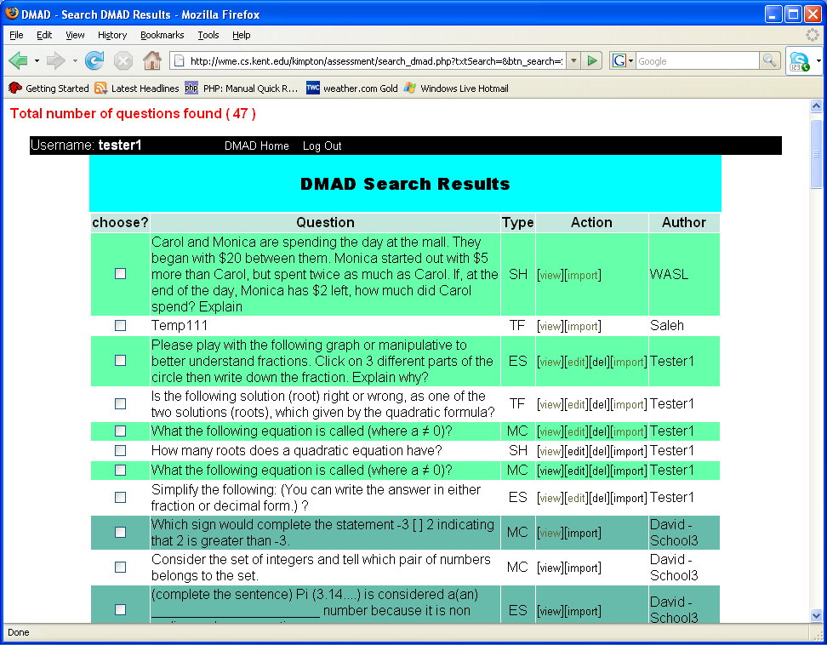
Figure A6: Search Result Page

Step A1-6: From the "Search Result Page" you can see the resulted questions, their types, and authors. If you are the author of a question then you can [edit] or [delete] it, otherwise you will see only two links [view] and [import] to view or import a question into your own test (if you already created one). However, after you import a "copy" of a question then that's yours! You can edit, change, delete, or even export it later to the assessment bank as a new question.

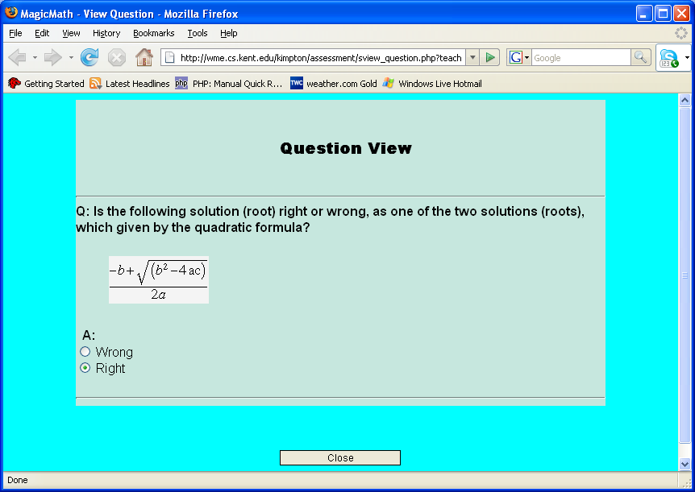
Figure A7: Question View Page

Activity A2: Creating an Assessment Test

Step A2-1: After login and from the "assessment main page", click on "Make a New Test": to create a new assessment test.
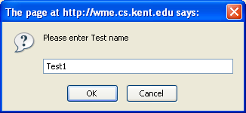
Figure A8: New Test Form

Step A2-2: Enter a test name and the program will bring you to this page.

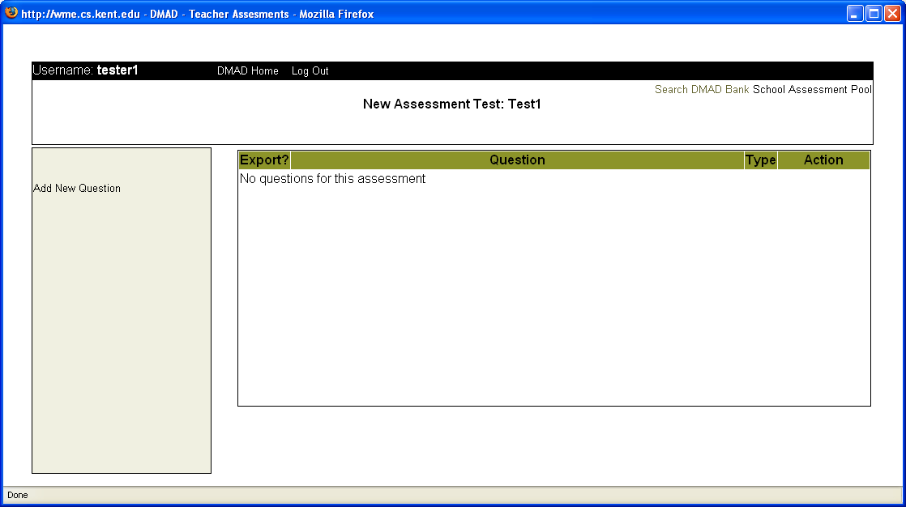
Figure A9: New Test Page

Step A2-3: Click "Add New Question" to create new questions with specific type, then click the button "CONTINUE".
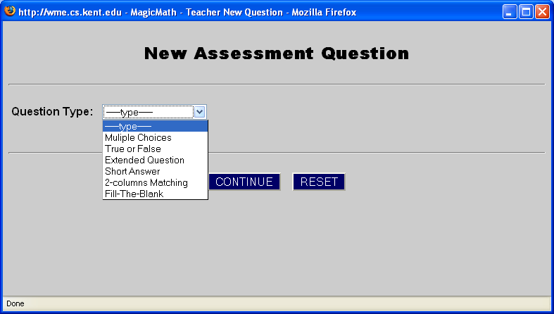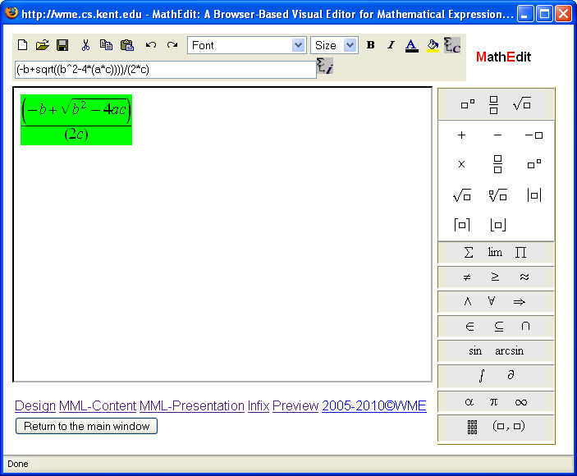
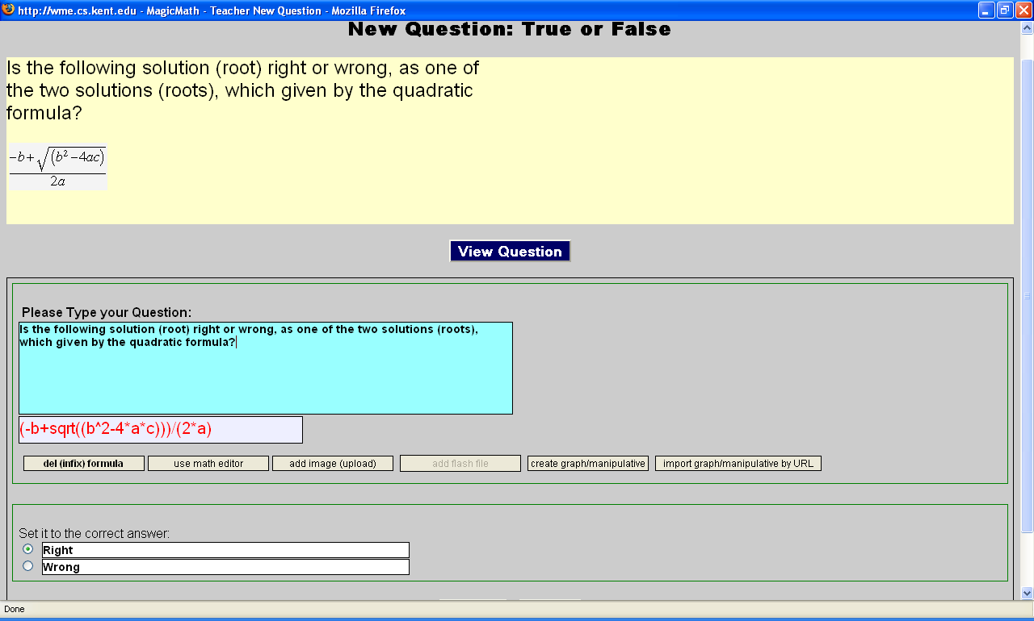
Figure A10: New Question Forms with Math Formulas

Step A2-4: Please write the question in the box and use any of the buttons listed. For example, to enter a root (solution) for a quadratic equation, click on "add (infix) formula" button and enter the infix in the appearing box or click on "use math editor" to use an external Math editor to enter Math expression.
Step A2-5: To include a manipulative or geometric graph using an external WME geometric editor (geoSVG) in a question, click on "create graph/manipulative" button to create/draw your own geometric graph or click "import graph/manipulative by URL" to enter the manipulative URL and the graph will be automatically included.

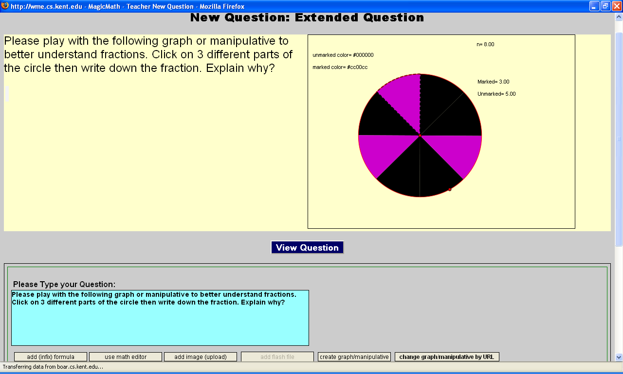
Figure A11: New Question Forms with Geometric Graph

Step A2-6: You can also use upper links "Search DMAD Bank" or "School Assessment Pool" to search for questions, view questions, or click the link "import", along with each question, to import questions to your new test.
Step A2-7: From the New Assessment Page, and after you are done with creating or importing questions to your test, click "DMAD Home" link on the top to return to the DMAS main page.

Activity A3: Managing an Assessment Test

Step A3-1: From DMAS main page click "Manage Tests" link to manage your assessment tests such as renaming/editing/deleting a test, adding, viewing, editing, or deleting questions, setting test scores, publishing a test, grades administration, etc.

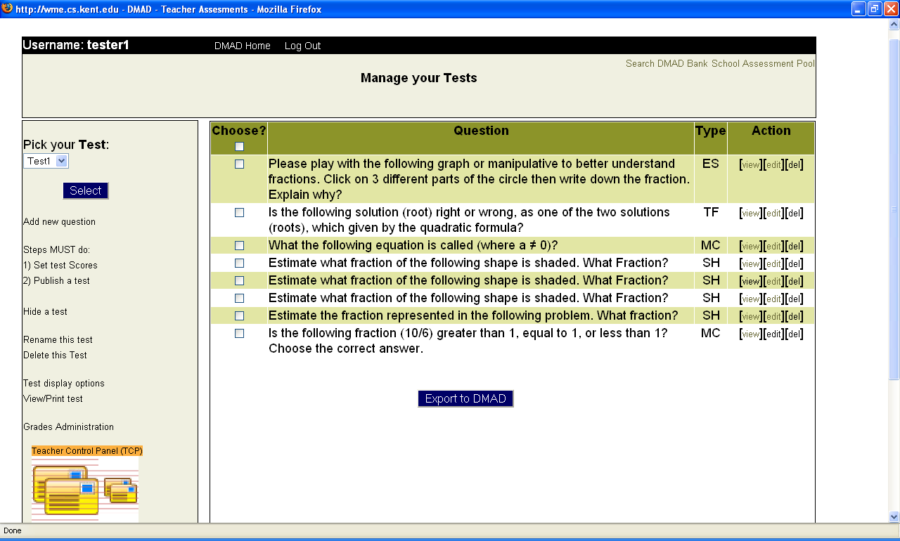
Figure A12: Manage Tests Page

Step A3-2: As you can see the questions, their types, and authors. You can click on the links under action to [view], [edit] or [delete] a question. You can also select questions to export to the assessment bank by checking checkboxes and then click the button "Export to DMAD".

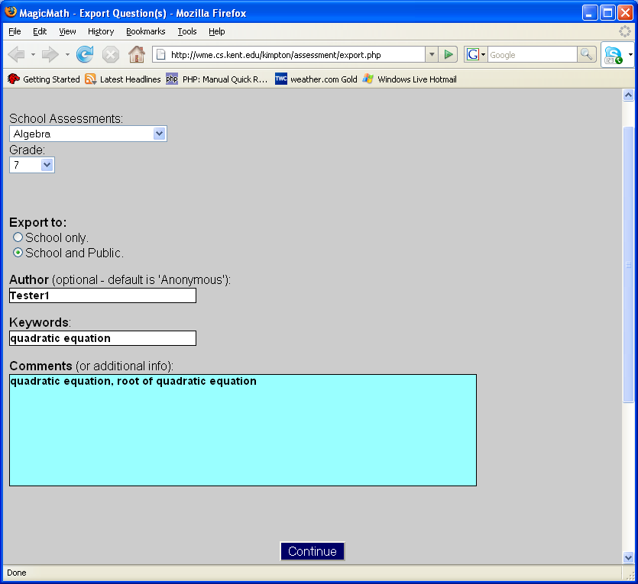
Figure A13: Export Questions to the Assessment bank

Step A3-3: You choose the category (Algebra, Geometry, etc.), the grade level, where to export questions (to your own school only or to the global bank), author's name (default is anonymous for privacy), Keywords, and comments. Then click "Continue" button to export.

Step A3-4: After you are done with editing your test questions and the test is ready, click the link "1) Set Test Scores" to choose a test display type and set scores for each question.

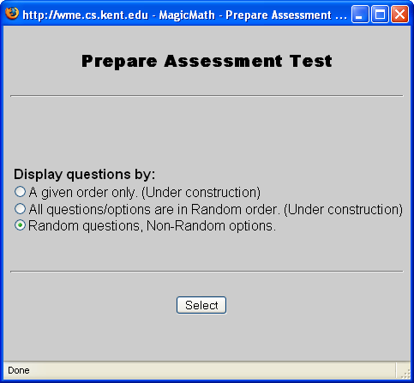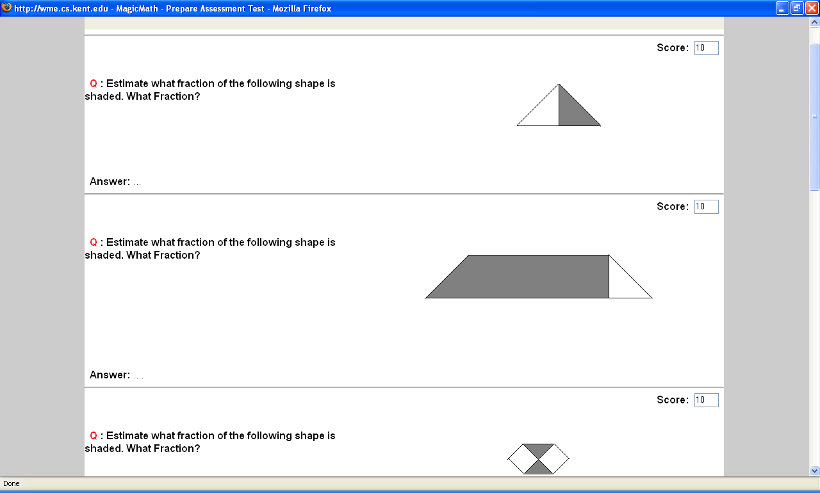
Figure A14: Prepare Test Page

Step A3-5: From Manage Tests page, click the link "2) Publish Test" to publish and display the test to students so that they can take the test.

Activity A4: Conducting an online Assessment Test and Grades Administration

Step A4-1: After publishing the test and making it available to students online (from last step of previous Activity), students can go to your test page (every teacher has a unique page) and the link will look like: (http://wme.cs.kent.edu/kimpton/assessment/userid.php) (for example, if your userid is "tester1" then your test page address will be: http://wme.cs.kent.edu/kimpton/assessment/tester1.php and students will see the available test given by their teacher automatically.
Step A4-2: Students click on the test link, enter only their names, and then wait for authorization from their teacher. This way the teacher can avoid wasting time and problems of the standard login systems in which students may forget their userids/passwords (especially students in early ages) or exchange their userids/passwords.

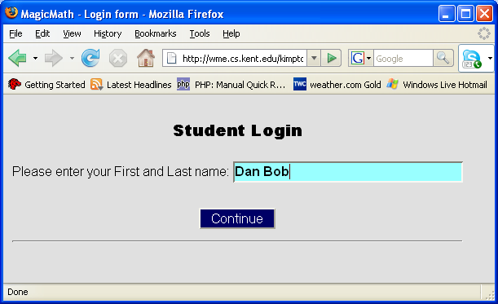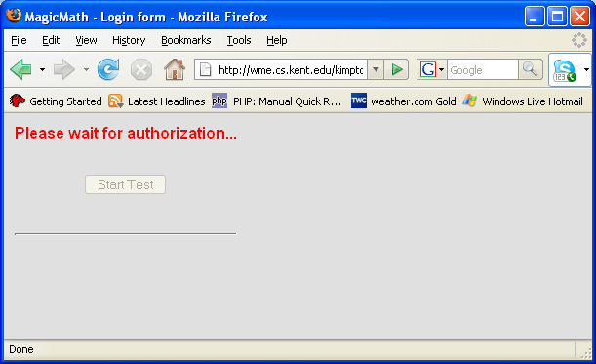
Figure A15: Student Login Form

Step A4-3: The teacher now, from the "Manage your Tests" page, can click on "Teacher Control Panel" (TCP) icon to open the test control window. You will see student names listed who are waiting for authorization to take the test. Click checkboxes beside student names and then click "Authorize/Retake" button to give students authorization/permission to take the test (or "Remove" to prevent and delete unauthorized names from taking the test).

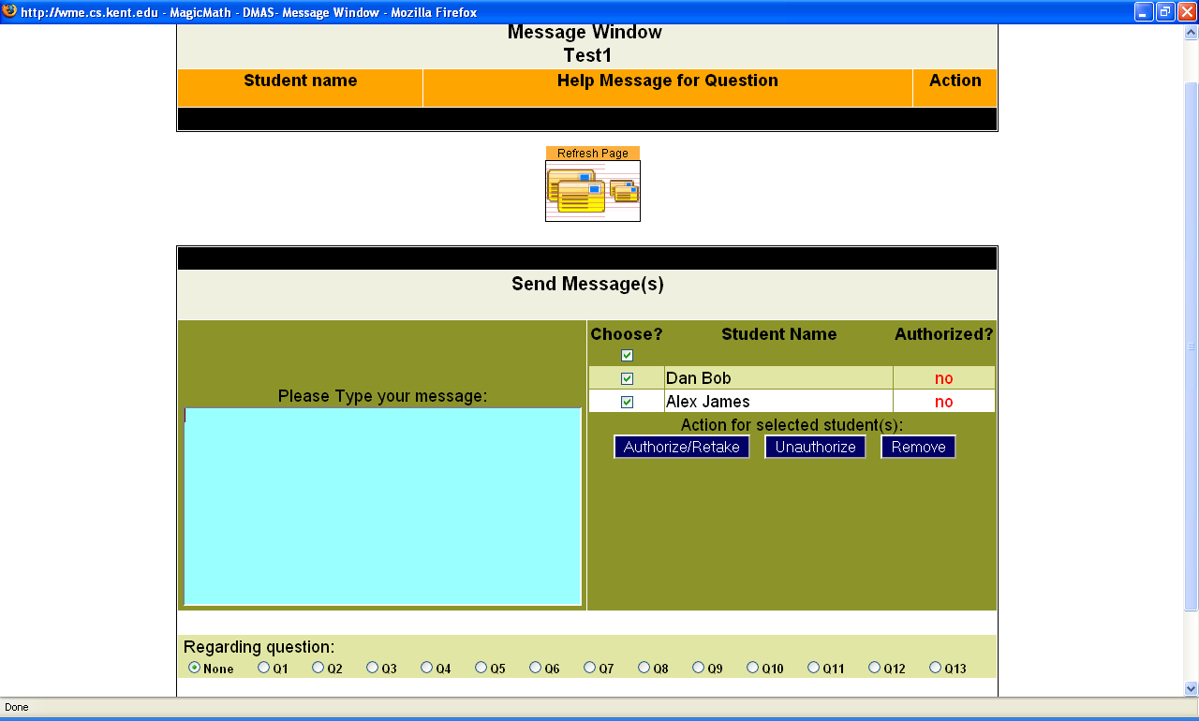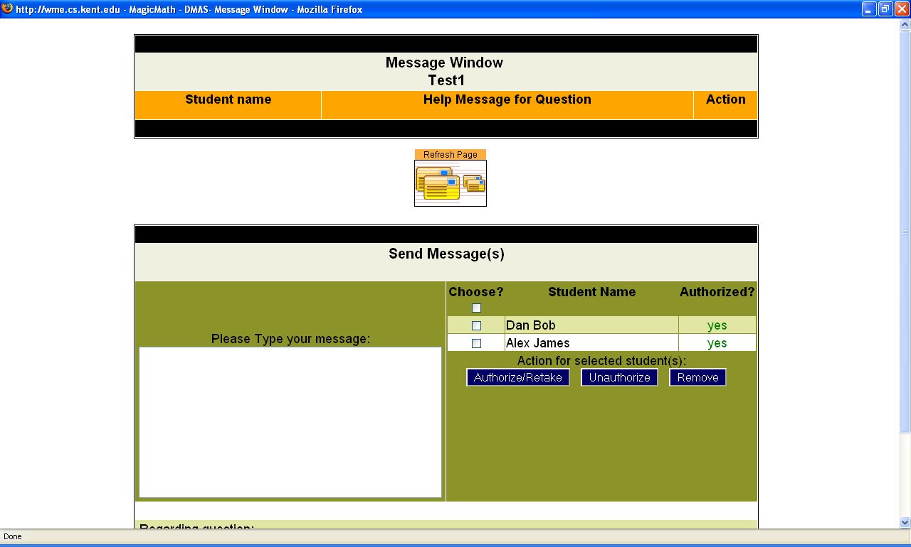
Figure A16: Teacher Control Panel (TCP)

Step A4-4: Now the authorized student will see a pop-up button "Start Test". He/she can click this button and go to take the test. A Student can view all test questions on one page or click "switch to: view one question per page" on the top to see one question at a time. "Question quick links" at the top are to go directly to individual question. A student clicks "Post my answer for this question" to submit her answer for a question accumulatively.

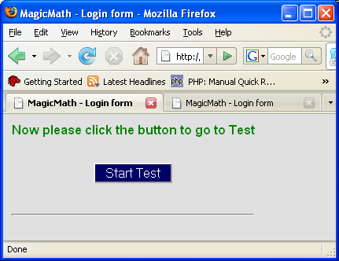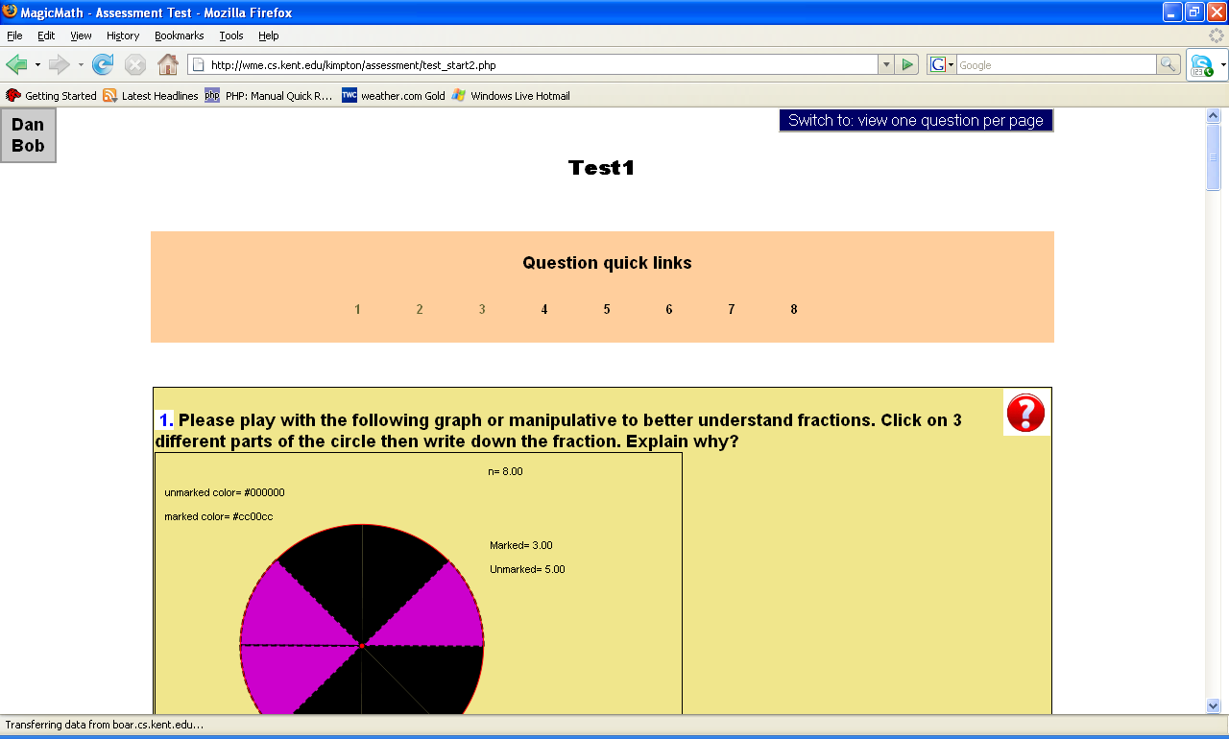
Figure A17: Student Test Page

Step A4-5: The teacher can monitor and see all student grades in real-time while students taking the test. From the "Manage your Tests" page, click on "Grades Administration" link, and from the pop-up window, you pick a test name and a display grades method (by a student name or by a question). From there you will see the real-time automatic grading, statistics, percentages, and even know who got the right/wrong answers.

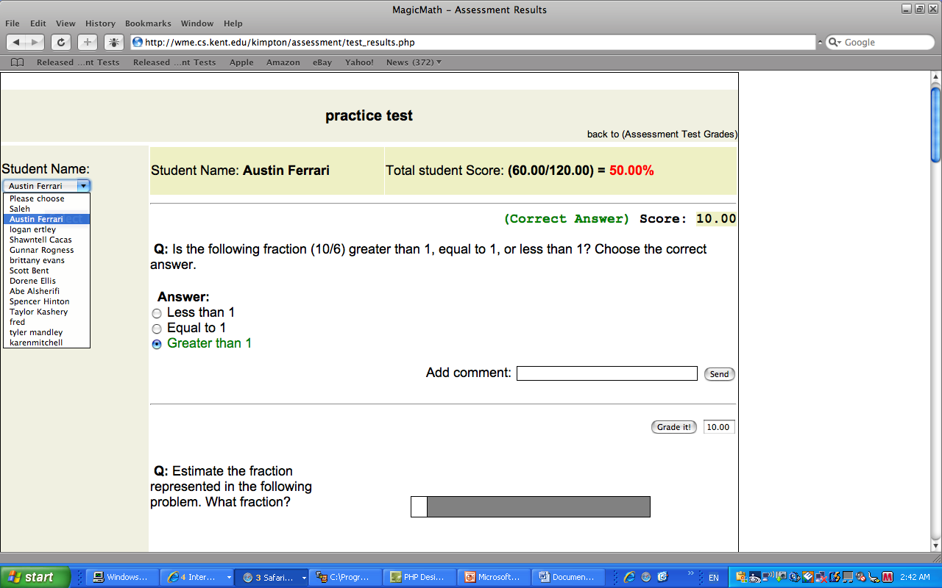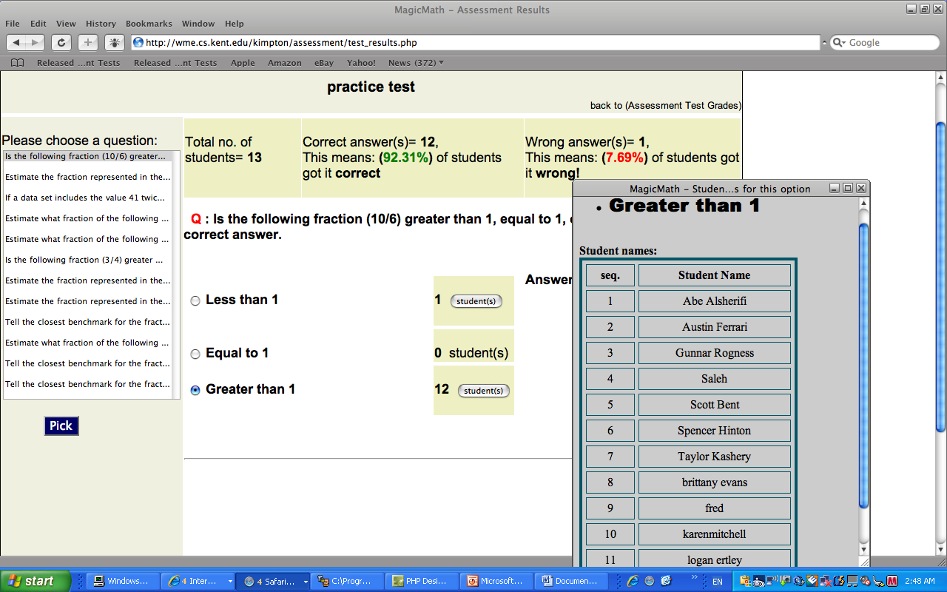
Figure A18: Grades Administration

Step A4-6: The teacher can monitor all students from the teacher terminal in real-time and either verbally guide the whole class on certain points or interact privately with one or more students via Teacher-Student Interaction Mechanism (TSIM) as instant text-messaging provided by the assessment system. Also students at any time of test can “click” help button asking for help from the teacher.

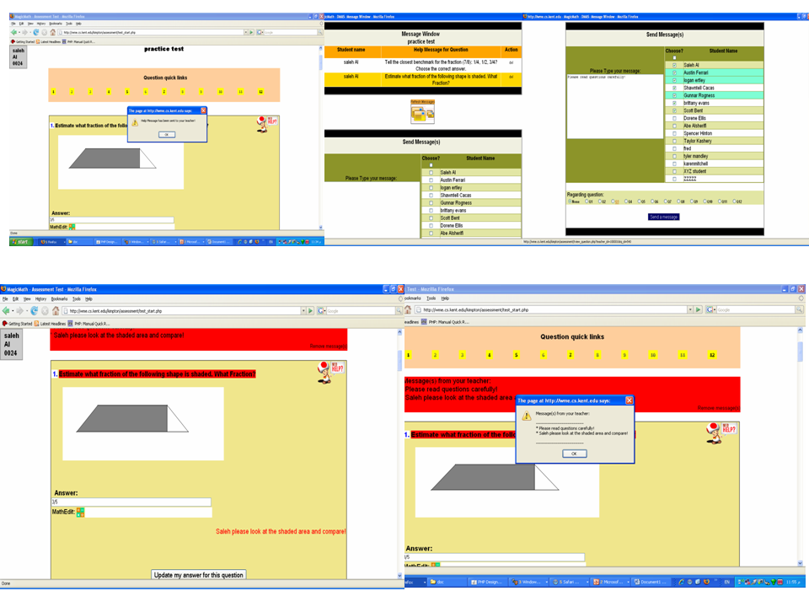
Figure A19: Teacher-Students Interaction Mechanism

About the Author

Saleh Al-shomrani is a Ph.D. candidate and a Graduate Assistant in the Department of Computer Science at Kent State University, OH, USA. He has a Bachelor degree (B.Sc) in Computer Science from King Abdulaziz University, Saudi Arabia and a Master of Science (MS) in Math/Computer Science from Ohio University, Athens Campus, USA. He was selected by the Graduate Student Senate (GSS) for the research award for 2005 from Kent State University on April 11 2005. His current research is on Web technologies for mathematics education. In 2004, he joined the research group directed by Dr. Paul Wang, Director of the Institute for computational Mathematics at Kent State, and participated in the Web-based Mathematics Education (WME) project. Saleh is designing and implementing DMAS assessment system using various Web languages and technologies to support teaching and learning mathematics on the Web.

