CS 69995 & CS 79995 ST: Probabilistic Data Management
Homework 1
Instructor: Xiang Lian
Due Date: Please refer to the course website

1. Please list 3 real applications that involve imprecise and uncertain data. Explain how the uncertainty (or probability) can be obtained for probabilistic data. [30 points]

2. What are the categories of uncertain data? Please explain the criterion you classify uncertain data. [20 points]

3. In Figure 1, assume that uncertain object a has 6 possible instances, and each of the rest uncertain objects, b ~ e, has 2 possible instances. Instances from the same uncertain object have equal appearance probabilities. [20 points]

3(a). How many possible combinations of object instances in this uncertain database that can appear in the real world? [10 points]

3(b). What is the nearest neighbor (NN) probability of uncertain object d when a is located at the red point? [10 points]

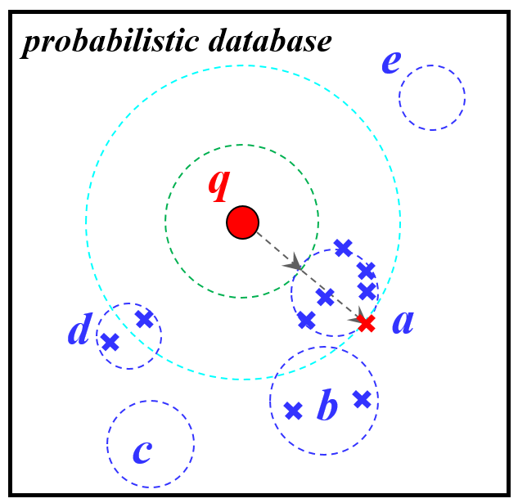
Figure 1. An example of probabilistic database.

4. In Table 1, please answer the following questions: [30 points]

4(a). How many possible worlds are there in the probabilistic database in Table 1? [10 points]

4(b). Please list all possible worlds and their appearance probabilities of the probabilistic database in Table 1. [20 points]

x-tuple t_{i} | Alternative t_{ij} | Attribute | Probability
t₁ | t₁₁ | 4 | 0.3
 | t₁₂ | 5 | 0.4
t₂ | t₂₁ | 2 | 0.7
t₃ | t₃₁ | 11 | 0.6
 | t₃₂ | 15 | 0.3
 | t₃₃ | 12 | 0.1
Table 1. An example of probabilistic table.

Solution: (You can add more rows in the table for possible worlds below)
Possible World, PW_{i} | Appearance Probability, Pr{PW_{i}}

Submission
Submit an electronic copy of your homework solution to the Blackboard.
18

