CS 43105 Data Mining Techniques
Homework 4
Instructor: Xiang Lian
Due Date: Please refer to the course website

1. Give the pseudo code of k-means clustering algorithm. [20 points]

2. Please write the pseudo code of agglomerative clustering algorithm. [20 points]

3. Please write the pseudo code of divisive clustering algorithm. [20 points]

4. Please explain what are core points, border points, and noise points. [15 points]

5. Please explain the pseudo code for DBSCAN algorithm in the lecture slides. [25 point]

Bonus Question [extra 20 points]

Please provide the centroids of 3 initial cluster assignments C1={x1, x2, x3}, C2={x4, x5, x6}, C3={x7, x8}, for the k-means algorithm over the data set in Figure 1, where K=3.
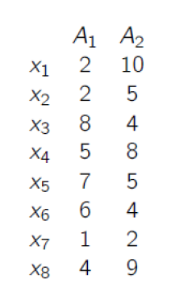
Figure 1. A 2D Database

Submission
Submit an electronic copy of your homework solution to the Blackboard.
18

