CS 63018 & CS 73018 Probabilistic Data Management
Homework 2
Instructor: Xiang Lian
Due Date: Please refer to the course website

1. Please search related topics on Bayes' formula on the Web, give the formula, and explain its rationale. [10 points]

2. Given P(X₁) and P(X₂ | X₁) for two nodes in the Markov sequence as shown in Figure 1, please provide the joint probability P(x₁, x₂). [10 points]
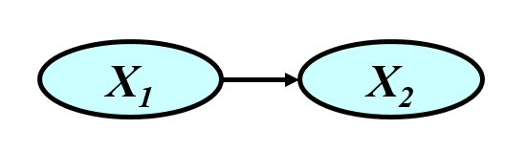
Figure 1. Markov Sequence

3. What are the joint probabilities of the Bayesian network below (Hint: using Bayes' formula)? [30 points]
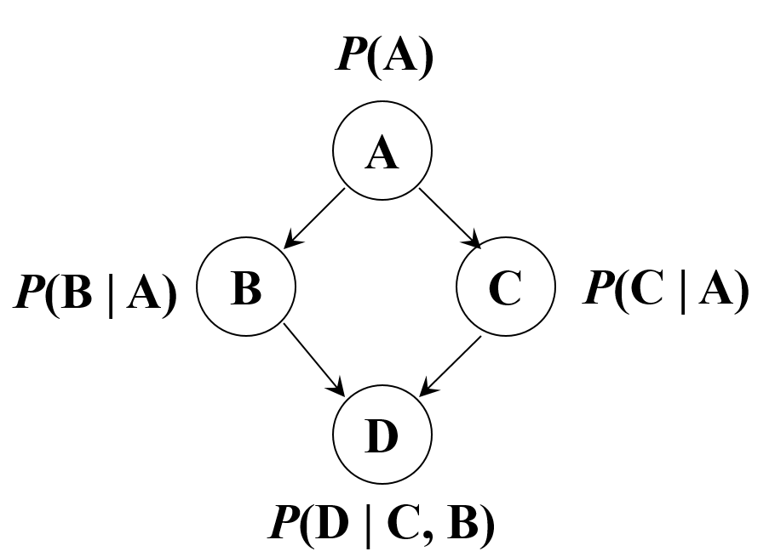
Figure 2. Bayesian Network

3(a). Joint probability P(A, B) [15points]

3(b). Joint probability P(A, C) [15 points]

4. Read the abstract and Sections 1-2 of the following SIGMOD 2003 paper. Write a description of the problem studied in this paper, including the motivation, problems/queries, and challenges of this problem. [50 points]

- Reynold Cheng, Dmitri V. Kalashnikov, Sunil Prabhakar. Evaluating Probabilistic Queries over Imprecise Data. In SIGMOD, 2003.
https://www.ics.uci.edu/~dvk/pub/SIGMOD03_dvk.pdf

Bonus Question What is the joint probability of P(A, B, C, D) in Figure 2 (Hint: using Bayes' formula for multiple times) [extra 20 points]

Submission
Submit an electronic copy of your homework solution to the Blackboard.
18

