# AI for DB (AI4DB)

**Homework 2 (AI Background)**

**Instructor:** Xiang Lian

In this homework, there are 5 questions, covering *Deep Neural Networks* (DNNs), *Convolutional Neural Networks* (CNNs), and *Recurrent Neural Networks* (RNNs). The maximum mark for this homework is **120 points**, which will be later scaled (to **12 points**).

1. **[Deep Neural Networks, 12 points]** List two (2) activation functions and two (2) loss functions that are commonly used for deep neural networks (DNNs).

2. **[Deep Neural Networks, 20 points]** Given a *deep neural network* (DNN) with an input layer (receiving 16 input signals) and 5 hidden layers (each layer with 32 neurons, fully connected between consecutive layers) in Figure 1, what is the space cost of storing the DNN parameters?

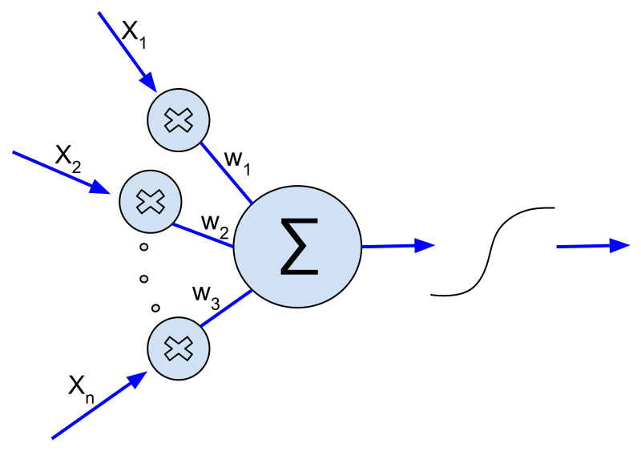

+ b

**Figure 1.** Deep Neural Network (*m* = 16 and *L* = 5).

2(a). What is the space cost between input layer and the first hidden layer? **[5 points]**

2(b). What is the space cost among 5 hidden layers? **[10 points]**

2(c). What is the total space cost of storing parameters of the DNN? **[5 points]**

3. **[Convolutional Neural Networks, 30 points]** As illustrated in Figure 2, assume that we have a 6×6 image in the blue channel.

|  |  |  |  |  |  |
| --- | --- | --- | --- | --- | --- |
| 0 | 2 | 3 | 2 | 1 | 4 |
| 2 | 0 | 6 | 4 | 2 | 3 |
| 2 | 6 | 3 | 2 | 0 | 0 |
| 0 | 6 | 3 | 0 | 2 | 1 |
| 3 | 2 | 5 | 2 | 1 | 9 |
| 1 | 0 | 4 | 7 | 3 | 1 |

**Figure 2.** Pixels in a 6×6 image.

3(a). If we use a 3×3 Sobel kernel (i.e., filter) in Figure 3 to apply the convolution operation on the 6×6 input image in Figure 2 **without padding**, what will be the output? **[10 points]**

|  |  |  |
| --- | --- | --- |
| 1 | 0 | -1 |
| 2 | 0 | -2 |
| 1 | 0 | -1 |

**Figure 3.** 3×3 Sobel kernel.

|  |  |  |  |
| --- | --- | --- | --- |
|  |  |  |  |
|  |  |  |  |
|  |  |  |  |
|  |  |  |  |

3(b). If we use a 3×3 Sobel kernel (i.e., filter) in Figure 3 to apply the convolution operation on the 6×6 input image in Figure 2 **with zero padding**, what will be the output? **[10 points]**

|  |  |  |  |  |  |
| --- | --- | --- | --- | --- | --- |
|  |  |  |  |  |  |
|  |  |  |  |  |  |
|  |  |  |  |  |  |
|  |  |  |  |  |  |
|  |  |  |  |  |  |
|  |  |  |  |  |  |

3(c). If we apply the **max pooling** on the 6×6 input image in Figure 2 and obtain a 3×3 convolutional layer, please provide the resulting layer? **[10 points]**

|  |  |  |
| --- | --- | --- |
|  |  |  |
|  |  |  |
|  |  |  |

4. **[Recurrent Neural Networks, 24 points]** Please describe the term/problem/algorithm: (1) Gated Recurrent Unit (GRU), (2) Vanishing Gradient Problem, and (3) backpropogation through time (BPTT) algorithm in Recurrent Neural Networks (RNNs). It is recommended to use figures/examples to better illustrate the term, problem, or algorithm. Cite the sources if you use any materials/figures from these sources.

5. **[Long Short-Term Memory, 14 points]** Please describe the Long Short-Term Memory (LSTM), including the structure/workflow of LSTM and its applications. Cite the sources if you use any materials/figures from these sources.

**Bonus Question** **[20 points]** Challenge yourself to answer this bonus question for extra credits.

Please select one type of learning model (e.g., DNN, RNN, or LSTM) and provide a tutorial (with descriptions, screen captures, and code) on how to construct, train, and test this model. You can use any programming language (e.g., python, C++, etc.) or IDE tool (e.g., Pytorch, TensorFlow, etc.).

## Submitting Your Assignment

*All work must be your own. Copying other people’s work or from the Internet is a form of plagiarism and will be prosecuted as such.*

You may submit a Microsoft Word (.docx) document as an attachment using the **Canvas** Assignment tool. If you attach a document for your assignment, be sure to include your name in the text of the document and in the name of the document.

* Select this assignment in **Canvas** Assignment tool where you submit your work.
* You can submit multiple times, and only the last submission attempt will be considered for grading.
* Submissions sent by email will NOT be accepted.