CS 49995 & CS 63016 ST: Big Data Analytics
Homework 3
Instructor: Xiang Lian
Due Date: Please refer to the course website

1. Please list two major differences (or improvement) of X-tree from R*-tree. [10 points]

2. Please list at least 2 distance functions that are metric distances, and at least 2 distance functions (or similarity measures) that are non-metric distances. For each distance function, give the reason why it is (or is not) a metric distance, and give references or URL links. (Hint: please search on the Web or Wikipedia to find the answers) [20 points].

3. Please read the lecture slide of Chapter 3, "Range Queries Over M-Tree", and prove the pruning strategy for the range query below (Hint: use the triangle inequality) [30 points]:
If |d(O_{p}, Q)-d(O_{r}, O_{p})|>r(Q)+r(O_{r}), then d(O_{r}, Q) > r(Q) + r(O_{r}) holds and node centered at O_{r} with radius r(O_{r}) can be safely pruned.
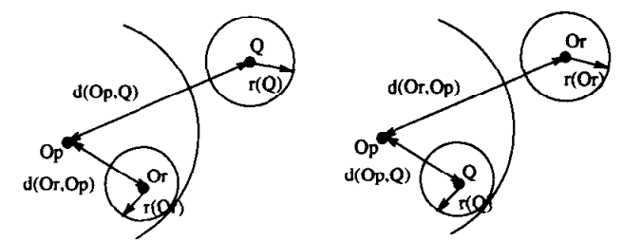
4. (The Curse of Dimensionality) [40 points]
4a. What is the curse of the dimensionality? Please provide the reason for the dimensionality curse. [10 points]

4b. Read Section 2 of the following paper, and write a short survey about existing dimensionality reduction techniques and high dimensional data structures mentioned in this section (Please cite reference papers in your survey and provide a list of reference papers after the survey. You may need to read abstract or introduction of some reference papers, if they are unclear in the section. Note: please use your own words to describe the techniques; DO NOT copy any sentences from the paper). [30 points]
H. T. Shen, X. Zhou, and A. Zhou. An adaptive and dynamic dimensionality reduction method for high-dimensional indexing. In VLDBJ, 2006. http://staff.itee.uq.edu.au/zxf/_papers/VLDBJ06.pdf

Bonus Question [20 extra points]
6. Read Section 2.2 of the following paper, as well as the cited papers in this subsection, and write a short survey about the intrinsic dimensionality. (Note: please use your own words to describe the problem definition and solutions; DO NOT copy any sentences from the paper).
R.F.S. Filho, A. Traina, C. Traina, and C. Faloutsos. Similarity search without tears: the OMNI-family of all-purpose access methods. In ICDE, 2001. http://repository.cmu.edu/cgi/viewcontent.cgi?article=1565&context=compsci

Submission
Submit an electronic copy of your homework solution to the Blackboard.

