CS 49995 & CS 63016 ST: Big Data Analytics
Homework 5
Instructor: Xiang Lian
Due Date: Please refer to the course website

1. Read the lecture slides about NN pruning heuristics, and write the pseudo code of computing the minimum distance, mindist(q, E), between a query point q and an MBR node E in d-dimensional space. [20 points]

2. Read the lecture slides about NN pruning heuristics, and write the pseudo code of computing the maximum distance, maxdist(q, E), between a query point q and an MBR node E in d-dimensional space. [20 points]

3. Read the lecture slides about the pruning conditions for Simple Point Method (SPM) of GNN queries, and prove the pruning condition below (Hint: you may need to read the original paper of GNN and use the triangle inequality for the proof) [30 points]
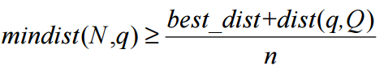

4. Given an aR-tree (as mentioned in the reference below) I and a hyperrectangular query region Q, please write the pseudo code of retrieving the number of objects in Q by traversing the aR-tree. [30 points]
I. Lazaridis and S. Mehrotra. Progressive Approximate Aggregate Queries with a Multi-Resolution Tree Structure. In SIGMOD, 2001.

Bonus Question [20 extra points]
5. Find one paper (in SIGMOD, PVLDB, and ICDE) related to big data analytics (indexing or querying) you are interested in.
- Provide the reference of this paper;
- Briefly describe the problem and solutions of this paper; and
- Explain the main contributions of this paper.

Submission
Submit an electronic copy of your homework solution to the Blackboard.

